MODEL DEVELOPMENT PROCESS

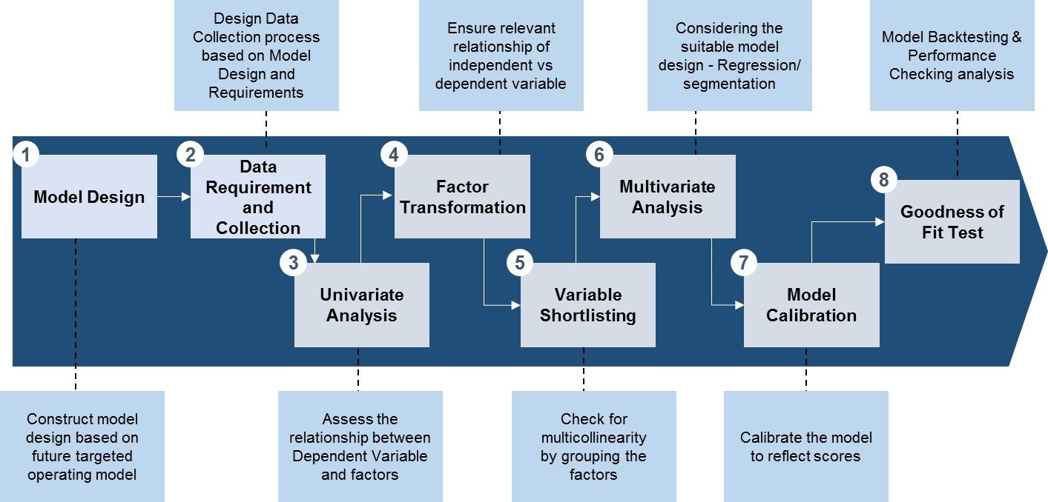

Model Design
Discussed the performance window, list of independent variables, bad definition, cscore definition and exclusions. Hence, the portfolio performance data from the period September 2014 to May 2016 was used for the observation period. Rolling one month of every observation month (October 2014 – Jun 2016) is taken as the performance period. Portfolio performance variables as well as internal application level variables were used as predictive characteristics.
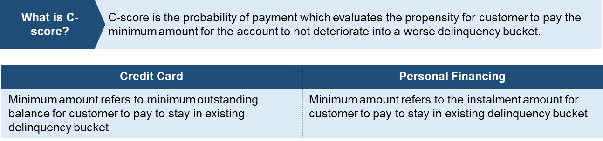

Exclusion Rules
As discussed during the workshop and at the modelling focus group meeting, accounts that have undergone exceptional events such as those listed below, are excluded from the model development sample.
- Corporate Cards (Credit Card only)
- Bankrupt
- Deceased
- Fraud
- Dispute
- Customers with outstanding balance of RM200 and below
- New customers (less than 6 months) who are delinquent
- High profile customers (VIP)
- 90+ Days Past Due

Analytical Tools
SAS Enterprise Guide 7.1 (“SAS EG”) is used to access data in the datamart for data preparation. Data cleansing, variable creation and sampling were done in SAS EG to create the modelling sample. SAS Enterprise Miner Client 14.1 (“SAS EM”) is used for building the regression models from the modelling sample created in SAS EG.
Environment | IP Address | SAS Servers | Tools
Production | 10.188.0.91 | SAS EM | SAS Enterprise Guide 7.1  SAS Enterprise Miner Client 14.1

DATA SAMPLE SELECTION
This section details the process of data collection, data processing and data sample selection.

Data Collection

Table Name | Description | Data Source
CUSTOMER | Customer demographic data from October 2013 to September 2016 (Credit Card and Personal Financing) | Data Warehouse
CREDIT_CARDS | Performance data from October 2013 to September 2016 | Data Warehouse
CONSUMER_LOAN | Personal Finance performance data from October 2013 to September 2016 | Data Warehouse
DEPOSITS | Current Account, Saving Account and Fixed Deposit Information | Data Warehouse
DWH_CUST_ACCT_RELATIONS | Customer account table with linking keys (CUS_NO, ACCT_NO and CIF_KEY) | Data Warehouse
NON_PERFORMING_LOAN | Non-Performing Loan Accounts | Data Warehouse
DWH_PRODUCT_CODES | Product codes for Credit Card and Personal Financing products | Data Warehouse
T_ACT_REACT | Action Reaction table Summary | DCRMS
T_MT_ACTS | Action table | DCRMS
T_MT_REACTS | Reaction table | DCRMS
T_PTP_DETAILS | Promise to Pay Details | DCRMS
T_PTP_SUMMARIES | Promise to Pay Summary | Data Warehouse
T_CASES | Cases table | Data Warehouse
APPLICATIONS | Debt Service Ratio field | Activate

Challenges & Data Integrity Issues
We observed a number of data issues at the early stage of data analysis. These are listed below.
No. | Limitation | Solution
1 | Credit card:  D_CONDUCT_OF_ACCONT_XX field was assumed to be as of month end as provided by DWH | This was replaced with D_DELINQUENT_XX.
2 | Credit Card:  Unable to derive Days Past Due variables | This was replaced with Delinquency buckets.
3 | Credit Card:  The transactor indicator field is missing from Jan 2014 to August 2015
4 | Unable to locate Insurance field,  D_STATUS_CODE  (codes: 49001, 49002,49003, and 49007) in DWH Account Status Codes table
5 | DCRMS Data from October 2015 to September 2016 | Self-cure model development data is from October 2015 to September 2016
6 | CPF accounts are PF accounts found in the DWH Credit Card table | CPF accounts will be score as part of the Credit Card models
7 | Difficulty in tagging Self-Cure accounts | Used business definition as a guide to tag Self-cure accounts.

Base Creation
Modeling data base was created from Credit Card, Deposit, Insurance and Customer tables.
Data Sample | Time Period | Description
Observation Month | 30 Sept 2014 – 31 May 2016 | The time at which variables used for prediction are measured
Performance Month | 31 Oct 2014 – 31 Aug 2016 | The time period over which the dependent variable or the target is tracked.
Out of time validation | 30 Jun 2014 – 31 Aug 2016 | The time period at which validation is conducted

Independent Variables Creation
For modelling, it is important to determine what independent variables drive the dependent variable. A preceding step is to ‘create’ the independent variables. The variable creation process is necessary for the following main reason:
- Standardising attributes:
Attributes can be presented in different ways / formats and this needs to be standardised for the data to make sense. This can be done with mapping tables or simple ‘if then’ statements. For example: The raw data from PAST_DUE_DATE can be grouped into three categories such as ‘Begin’, ‘Middle’, and ‘End’ due dates.
- Derived variables:
Some variables are derivations of other variables. For example, ‘OUTSTANDING_BAL’ is derived from two variables: ‘D_CURR_BALANCE’ and ‘D_INST_BAL‘.
Several discussions were conducted for the project team to finalise the list of independent variables. The finalised list of independent variables covers following data: account behaviours, customer information as well as insurance information.
Refer to appendix for variables created for both credit card and personal finance models.

Dependent Variable
Compare observation and performance month status to tag the dependent variable, pay or non-pay. For the Credit Card and Personal Finance Models, the dependent variable is binary in nature, except the Credit Card SelfCure Model which is a probability model.
Target | Scenarios
1 (Non-pay) | Forward Flow
0 (Pay) | Pushback
0 (Pay) | Stayover

For the Credit Card Self-Cure model, the flag is created by considering those accounts which are present in DCRMS, but have not gone through any action and is cured within the same month.

Model Development Samples
Some accounts are not suitable to be selected as modeling sample as they might skew the model development results. Below is the waterfall chart representing the modeling samples for both Credit Card and Personal Financing.

Population Stability Index (PSI)
The PSI is a quantitative metric used to assess whether there has been a fundamental change over time or between samples. The threshold for PSI is <0.25. For the model development purpose, we have done a PSI checking on the sampled population to ensure that no biases exist on the sampled pool.

Credit Cards CScore
Status-Tracking Month | Population (R) |  | Sample (T) |  | U=R-T | W=ln(R/T) | U*W
Status-Tracking Month | # Accounts | % Accounts | # Accounts | % Accounts | U=R-T | W=ln(R/T) | U*W
1:Current | 236,232 | 92.6% | 59,713 | 88.0% | 0.05 | 0.051 | 0.002
2:Xdpd:1-29 | 131,88 | 5.2% | 4,830 | 7.1% | -0.02 | -0.320 | 0.006
3:30-59 | 3,597 | 1.4% | 1,963 | 2.9% | -0.01 | -0.719 | 0.011
4:60-89 | 2,076 | 0.8% | 1,320 | 1.9% | -0.01 | -0.872 | 0.010
Total PSI |  |  |  |  |  |  | 0.029

Credit Cards Pushback-Stayover
The PSI for this model is high due to the biased sampling of 50%. Close monitoring is required for this model through the model monitoring template and model tracking sheet.
Status-Tracking Month | Population (R) |  | Sample (T) |  | U=R-T | W=ln(R/T) | U*W
Status-Tracking Month | # Accounts | % Accounts | # Accounts | % Accounts | U=R-T | W=ln(R/T) | U*W
1:Current | 5,183,577 | 89.4% | 284775 | 48.5% | 0.41 | 0.61 | 0.251
2:X dpd:1-29 | 442,187 | 7.6% | 236331 | 40.2% | -0.33 | -1.66 | 0.541
3:30-59 | 110,298 | 1.9% | 49552 | 8.4% | -0.07 | -1.49 | 0.097
4:60-89 | 59,196 | 0.1% | 16913 | 2.9% | -0.02 | -1.03 | 0.019
Total PSI |  |  |  |  |  |  | 0.909

Personal Finance Cscore
Status-Tracking Month | Population (R) |  | Sample (T) |  | U=R-T | W=ln(R/T) | U*W
Status-Tracking Month | # Accounts | % Accounts | # Accounts | % Accounts | U=R-T | W=ln(R/T) | U*W
1:Current | 6,518,162 | 83.0% | 801,630 | 72.1% | 0.11 | 0.141 | 0.015
2:X dpd:1-29 | 960,601 | 12.2% | 183,133 | 16.5% | -0.04 | -0.298 | 0.013
3:30-59 | 242,957 | 3.1% | 73,941 | 6.7% | -0.04 | -0.765 | 0.027
4:60-89 | 128,259 | 1.6% | 52,666 | 4.7% | -0.03 | -1.065 | 0.033
Total PSI |  |  |  |  |  |  | 0.088

Personal Finance SelfCure
Status-Tracking Month | Population (R) |  | Sample (T) |  | U=R-T | W=ln(R/T) | U*W
Status-Tracking Month | # Accounts | % Accounts | # Accounts | % Accounts | U=R-T | W=ln(R/T) | U*W
1:Current | 6,518,162 | 83.0% | 868,654 | 69.1% | 0.14 | 0.184 | 0.026
2:X dpd:1-29 | 960,601 | 12.2% | 44,245 | 27.4% | -0.15 | -0.805 | 0.122
3:30-59 | 242,957 | 3.1% | 35,617 | 2.8% | 0.00 | 0.089 | 0.000
4:60-89 | 128,259 | 1.6% | 9,361 | 0.7% | 0.01 | 0.786 | 0.007
Total PSI |  |  |  |  |  |  | 0.155

Personal Finance Pushback-Stayover
Status-Tracking Month | Population (R) |  | Sample (T) |  | U=R-T | W=ln(R/T) | U*W
Status-Tracking Month | # Accounts | % Accounts | # Accounts | % Accounts | U=R-T | W=ln(R/T) | U*W
1:Current | 1,730,728 | 77.9% | 348,581 | 68.0% | 0.10 | 0.135 | 0.013
2:X dpd:1-29 | 325,527 | 14.6% | 124,165 | 24.2% | -0.10 | -0.504 | 0.048
3:30-59 | 102,260 | 4.6% | 29,519 | 5.8% | -0.01 | -0.225 | 0.003
4:60-89 | 64,225 | 2.9% | 10,047 | 2.0% | 0.01 | 0.388 | 0.004
Total PSI |  |  |  |  |  |  | 0.068

Outlier and Missing value treatment
Some variables may have extreme positive or negative values. Such values reduce the effectiveness of model and need to be capped. Capping is very important especially if the sample is small. Some guidance on this step:
- Replace the missing values with mean for non-skewed data, and median for skewed data
- Replace the missing values with logically correct numbers (eg: Treating all deposit amount missing to zero)
- Don’t cap unless the value is unrealistic (note: capping brings in loss of information )
- Cap to the next highest (of course, realistic) value.
- Cap so that the continuity is maintained.
- Eg: Outstanding balance related variables need to treat for outliers. Cap it at 99 percentile. Higher values cap it at 99 percentile and negative values at 0

PRELIMINARY ANALYSIS

Univariate Analysis
Univariate analysis was done to aid in the variable selection and data purging process. Variables that were found to have almost entirely missing, null, or one value were identified and dropped from the dataset. Below is the waterfall chart on variable selection for each model:

SUMMARY OF FINAL MODELS
The following section summarizes the final model selected throughout the modelling phase.

Credit Card Cscore Model
Summary table
Model Development Table (SAS EG) | EMMOD.CC_MODELING_DATA_V5
Good:Bad ratio | 75:25
Type of Model (SAS EM) | Stepwise Logistic Regression
Transformation | None
Model Validation Criteria | Training 70 (%) | Validation 30 (%) | Acceptance benchmark*
Kolmogorov-Smirnov Statistic | 56 | 57 | =>40
Roc Index | 85 | 85 | =>60
Classification Rate | 81 | 81 | =>40
Gini Coefficient | 70 | 70 | =>60

Factors | Description | Variable Type | Missing Value Treatment
D_M12_LATE_CHARGE_NO | Number of late charge payments in the last 12 months | Lending Behaviour | 0
NUM_ROLL_FWD_DB_3 | Number of roll forwards in delinquency bucket in the last 3 months | Lending Behaviour | Median = 0
D_TRANSACTOR_IND | Transactor/Revolver Index | Lending Behaviour | N/a
OBS_DELQ | Delinquency status in current month (Current/1-29/30-59/60-89) | Lending Behaviour | N/a
PRODUCT_CATNEW | Product Category | Product type | ‘Other’
INC_FD_BAL_L9 | Number of times increase in FD Balance within the last 9 months | Deposit | 0
LEN_AVG_UTIL_L12 | Average credit card utilization in last 12 months | Lending Behaviour | Mean = 48
DEM_AGE | Age of the customer | Demographic | Mean = 42
DEM_RACE | Race of customer | Demographic | ‘NA’

The Credit Card CScore model development process is as follows:
The target variable is binary (Pay – 0 vs NonPay – 1). Data was partitioned into train (70%) and validation (30%). An Information Value test (conducted in Base SAS) was used to shortlist the variables with criteria IV > 0.03. Then, the correlation among the list of predictor variables were examined. The multicollinearity among independent variables were identified using standard measures like Variance Inflation Factors (VIF), conditional index etc. Among the correlated variables, the most significant variables were identified using Wald-chi square statistics.
Using the Drop node in SAS EM, we drop the non-significant variables then run the Interactive Binning node for DEM_RACE. This node is to set Malay-Bumiputra as the base for comparison with other races. Lastly, we run the stepwise regression model to determine the significant variables for this model.
All model validation criteria passed.
Below is a snapshot of the SAS EMiner process flow for the Credit Card CScore model:
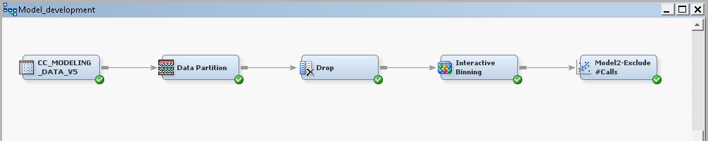

Credit Card Pushback-Stayover Model
Summary table
Model Development Table (SAS EG) | EMMOD.CC_PBSO_MODELING_DATA_V2
Good:Bad ratio | 50:50
Type of Model (SAS EM) | Regression
Transformation | Optimal Binning
Model Validation Criteria | Training 70 (%) | Validation 30 (%) | Acceptance benchmark*
Kolmogorov-Smirnov Statistic | 50 | 50 | =>40
Roc Index | 83 | 83 | =>60
Classification Rate | 75 | 75 | =>40
Gini Coefficient | 66 | 66 | =>60

Factors | Description | Variable Type | Missing Value Treatment
D_M12_ANNUAL_FEE_AMNT | Annual fee last 12 months | Lending Behaviour | 0
D_M12_LATE_CHARGE_AMNT | Late charge last 12 months | Lending Behaviour | 0
D_WAIVE_FLAGS_LATE_CHARGES | Late charges | Lending Behaviour | 0
PRODUCT_CATNEW | Product Category | Product type | ‘Other’
LEN_INC10PC_OS_L3 | Number of times the outstanding balance increased more than 10% in last 3 months | Lending Behaviour | Median = 0
DEM_RACE | Race of customer | Demographic | ‘NA’

The Credit Card Pushback-Stayover model development process is as follows:
The target variable is binary (Stayover – 0 vs Pushback – 1).
Taking into account of limited time, initial variable shortlisting was conducted in SAS EM using the Variable Shortlisting Node (with criteria of Chi-Square > 3.85). Then, a stepwise logistic regression was conducted to further shortlist the variables. The multicollinearity among these shortlisted variables were identified using standard measures like VIF, conditional index etc. Among the correlated variables, the most significant variables were identified using Wald-chi square statistics.
Using the sample node, a bias sampling of 50:50 was carried out to oversample the Pushback accounts as the stayover accounts were skewing the model. Then, Data was partitioned into train (70%) and validation (30%). Then, the variables were transformed, optimal binning, to reduce the skewness of the data. Lastly, a stepwise regression model was conducted to determine the significant variables for this model.
Below is a snapshot of the SAS EMiner process flow for the Credit Card Pushback-Stayover model:
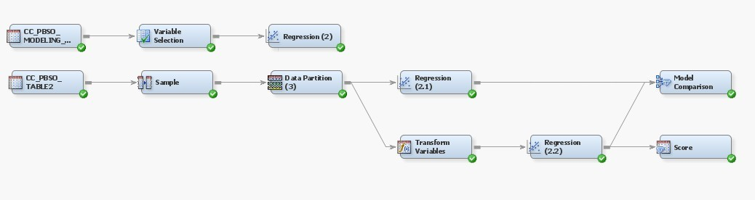

Personal Financing CScore Model
Summary table
Model Development Table (SAS EG) | EMMOD.PF_DEV_SAMPLE_V5
Good:Bad ratio | 50:50
Type of Model (SAS EM) | Regression
Transformation | Optimal Binning
Model Validation Criteria | Training 70 (%) | Validation 30 (%) | Acceptance benchmark*
Kolmogorov-Smirnov Statistic | 52 | 52 | =>40
Roc Index | 82 | 82 | =>60
Classification Rate | 76 | 76 | =>40
Gini Coefficient | 64 | 64 | =>60

Factors | Description | Variable Type | Missing Value Treatment
OPT_DEM_AGE | Customer Age | Demographic | Mean = 37
OPT_ORG_TERM | Loan Term | Lending Behaviour | Binned as “Missing”
OPT_SUM_SA_DR_AMT_L3 | SUM SA Debit Amount in last 3 months | Deposit | 0
OPT_INC5PC_SA_BAL_L6 | Increase 5% SA balance in last 6 months | Deposit | 0
OPT_SUM_BAL_SA_L3 | Sum of SA balance in last 3 months | Deposit | 0
OPT_LEN_PF_DEC5PC_OS_L12 | PF decrease more than 5% in outstanding in last 12 months | Lending Behavior | Binned as “Missing”
OPT_LEN_PF_PCT_DELQ_0_L12 | PF percentage delq in 0 in last 12 months | Lending Behaviour | Binned as “Missing”
OPT_LEN_PF_PMTINSRAT | AMT_COLLECTED_FOR_MONTH/len_pf_install | Lending Behaviour | Binned as “Missing”
OPT_LEN_PF_TOTAMT_PD | PF total past due amount | Lending Behaviour | Binned as “Missing”
OPT_MIN_DAY_PAST_DUE_L3 | Minimum day past due in last 3 months | Lending Behaviour | Binned as “Missing”
OPT_REL_PF_MAX_PMTINSRAT_L12 | PF maximum amount collected to installment ratio in last 12 months | Lending Behaviour | Binned as “Missing”
OPT_LEN_PF_CNT_ENPL_L12 | Sum of SA balance in last 3 months | Lending Behaviour | Binned as “Missing”
REL_PF_PRODCAT | Product category | Product Type | Binned as “Missing”

The Personal Finance CScore model development process is as follows:
The target variable is binary (Pay – 0 vs NonPay – 1). Data was partitioned into train (70%) and validation (30%). An Information Value test (conducted in SAS EG) was used to shortlist the variables with criteria IV > 0.1. Then, the correlation among the list of predictor variables were examined. The multicollinearity among independent variables were identified using standard measures like VIF, conditional index etc. Among the correlated variables, the most significant variables were identified using Wald-chi square statistics.
Then, the variables were transformed, optimal binning, to reduce the skewness of the data. Lastly, a stepwise regression model was conducted to determine the significant variables for this model.
All model validation criteria passed.
Below is a snapshot of the SAS EMiner process flow for the Personal Finance CScore model:
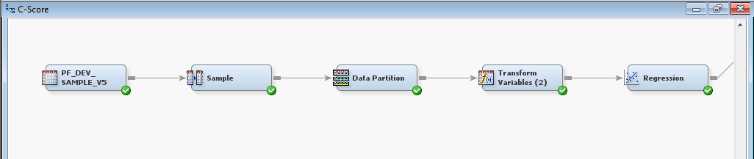

Personal Financing SelfCure Model
Summary table
Model Development Table (SAS EG) | EMOUTPUT.SC_PFVAR
Good:Bad ratio | 50:50
Type of Model (SAS EM) | Regression
Transformation | Optimal Binning
Model Validation Criteria | Training 70 (%) | Validation 30 (%) | Acceptance benchmark*
Kolmogorov-Smirnov Statistic | 36 | 36 | =>40
Roc Index | 76 | 76 | =>60
Classification Rate | 68 | 68 | =>40
Gini Coefficient | 51 | 51 | =>60

Factors | Description | Variable Type | Missing Value Treatment
OPT_TOTAL_DAYS_PAST_DUE | Total number of days past due | Demographic | Binned as “Missing”
OPT_LEN_PF_REM_PMT | Percentage of remaining number of payment/total term | Lending Behaviour | Binned as “Missing”
OPT_LEN_PF_NUMPMTARR | Number of payments in arrears | Lending Behaviour | Binned as “Missing”
OPT_LEN_PF_NUM_ROLL_BCK_DB_L6 | Number of times roll back within the last 6 months | Lending Behaviour | Binned as “Missing”
OPT_MAX_DAY_PAST_DUE_L9 | Maximum Days Past Due in the last 9 months | Lending Behaviour | Binned as “Missing”
LEN_PF_DUEDATE | Due date is Beginning, Middle or End of the month | Lending Behaviour | Binned as “Missing”
REL_PF_PRODCAT | Product Category | Product Type | Binned as “Missing”

The Personal Finance SelfCure model development process is as follows:
The target variable is binary (Non SelfCure – 0 vs SelfCure – 1).
Taking into account of limited time, initial variable shortlisting was conducted in SAS EM using the Variable Shortlisting Node (with criteria of Chi-Square > 3.85). Then, the multicollinearity among these shortlisted variables were identified using standard measures like VIF, conditional index etc. Among the correlated variables, the most significant variables were identified using Wald-chi square statistics.
The shortlisted variables and target were selected (EMMOD.PF_SC_MODEL_SAMPLED), the data was partitioned into train (70%) and validation (30%). Then, the variables were transformed, optimal binning, to reduce the skewness of the data. Lastly, a stepwise regression model was conducted to determine the significant variables for this model.
The KS and Gini Coefficient test failed to pass, however the ROC Index and Misclassification rate provides enough comfort to implement this model. Further enhancements should be carried out as this model was built with only one year of historical data.
Below is a snapshot of the SAS EMiner process flow for the Personal Finance SelfCure model:
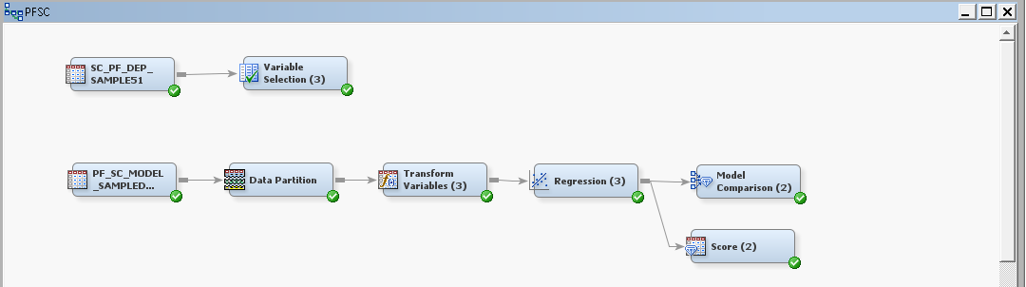

Personal Financing Pushback-Stayover Model
Summary table
Model Development Table (SAS EG) | EMOUTPUT. PF_PBSO_DEV_SAMPLE2
Good:Bad ratio | 75:25
Type of Model (SAS EM) | Regression
Transformation | None
Model Validation Criteria | Training 70 (%) | Validation 30 (%) | Acceptance benchmark*
Kolmogorov-Smirnov Statistic | 67 | 67 | =>40
Roc Index | 87 | 87 | =>60
Classification Rate | 81 | 81 | =>40
Gini Coefficient | 74 | 74 | =>60

Factors | Description | Variable Type | Missing Value Treatment
AVG_DAY_PAST_DUE_L3 | Average days past due in the last 3 months | Lending Behaviour | Binned as “Missing”
INC5PC_SA_BAL_L3 | Increase > 5% in Saving amount within the last 3 months | Deposit | 0
LEN_PF_INC5PC_OS_L9 | Increase > 5% in outstanding amount within the last 9 months | Lending Behaviour | Binned as “Missing”
LEN_PF_NUM_ROLL_BCK_DB_L6 | Number of roll backwards in the last 6 months | Lending Behaviour | Binned as “Missing”
LEN_PF_TIMES_COLLTOINS_03_L3 | Number of times delinquent when customer paid full installment amount in last 3 months | Lending Behaviour | Binned as “Missing”
PCT_TERM_REMAINING | Remaining number of payments/originals term | Lending Behaviour | Binned as “Missing”
REL_PF_AUTODEB_F | PF standing instruction account flag | Other | Binned as “Missing”
REL_PF_PRODCAT | Product category | Product Category | Binned as “Missing”

The Personal Finance Pushback-Stayover model development process is as follows:
The target variable is binary (Stayover – 0 vs Pushback – 1). The dataset was partitioned into train (70%) and validation (30%).
Taking into account of limited time, initial variable shortlisting was conducted in SAS EM using a stepwise logistic regression. The multicollinearity among these shortlisted variables were identified using standard measures like VIF, conditional index etc. Among the correlated variables, the most significant variables were identified using Wald-chi square statistics.
Using the Drop node in SAS EM, we drop the non-significant variables then run a stepwise regression model was conducted to determine the significant variables for this model.
All model validation criteria passed.
Below is a snapshot of the SAS EMiner process flow for the Personal Finance Pushback-Stayover model:
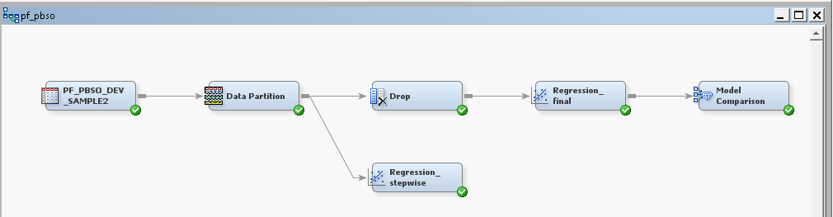

Credit Card Self Cure Model
Due to low classification rates from a regression and decision tree approach, developing the Credit Card Self-Cure Model using an algorithm. Following is the details of the logic:
Step 1: The criteria to tag self-cured accounts using DCRMS data:
1. Account table: PAST_DUE_DAY = 1 (Accounts in 1-29 bucket)
2. Action_Reaction table: Number of action taken = 0 (Cured and No Action)
3. Observation window: November 2015 to August 2016 (Exclude October 2015 data as it skewed the model)
Step 2: Calculate Probability of Selfcure:
Probability of selfcure *= | No. times SelfCure
Probability of selfcure *= | No. times Selfcure + No. times Not SelfCure
* Looking at the past 9 months (2015-11 to 2016-08)
Step 3: Assign Self_Cure tagging to accounts:
1. Probability of SelfCure >= 0.5
2. C-score > 0.9
Those accounts that fulfill the Step 3 criteria will be tagged as SelfCure = 1 (Yes)

Model Validation
No. | Test | Method | Threshold
1 | Kolmogorov-Smirnov Test (KS Test) | This test is used by comparing the distribution between “good” customer and “bad” customer. The differences between both of distribution indicates that the quality of the model to discriminate between “good” and “bad” customer. The difference is reflected by obtain the KS Score. | > 40%
2 | Receiver Operating Characteristic (ROC Index) | A Receiver Operating Characteristic Curve (ROC) is a standard technique for summarizing classifier performance over a range of trade-offs between true positive (TP) and false positive (FP) error rates | > 60%
3 | Misclassification Rate | Misclassification is a measure that compares the number of true goods and bads with the number of predicted goods and bads. | > 40%
4 | Gini Coefficient | Gini Coefficient measures the discriminatory power of the model using the Lorenz Curve. | > 60%
5 | Population Stability Index (“PSI”) | The PSI is a quantitative metric used to assess whether there has been a fundamental change over time or between samples. This is a common test among all models. | <10%

ROC CURVE/SCORES CUTOFF
Receiver Operating Characteristic curve (“ROC curve”) is a plot of the true positive rate (TPR-proportion of positives that are correctly identified by the model) against the false positive rate (FPR-number of negative events wrongly categorized as positive) for the different possible cut-off points of a diagnostic test. The ROC curve shows the tradeoff between sensitivity and specificity (any increase in sensitivity will be accompanied by a decrease in specificity).
The Credit Card Cscore model recommended cut off is 0.95, with true positive rate of 0.78 and a false positive rate of 0.22. This implies that by choosing accounts with cscore of 0.95 or above, we are correctly classifying 78% of good accounts, at the same time 22% accounts could be wrongly classified (Actual scenario is that the account is good, but the model predicts them as a bad account)
Details on the TPR and FPR at various cut-off values can be found in the appendix under Credit Card CScore Model Development and Results.
The ROC curve is shown below:

The Personal Finance Cscore model recommended cut off is 0.9, with true positive rate of 0.79 and a false positive rate of 0.26. Details on the cut off can be found in the appendix under Personal Finance CScore Model Development and Results
The ROC curve is shown below:

